**Project Design Phase-II**

**Data Flow Diagram & User Stories**

|  |  |
| --- | --- |
| Date | 20 June 2025 |
| Team ID | LTVIP2025TMID20320 |
| Project Name | Booknest: Where Stroies Nestle |
| Maximum Marks | 4 Marks |

**Data Flow Diagrams:**

A Data Flow Diagram (DFD) is a traditional visual representation of the information flows within a system. A neat and clear DFD can depict the right amount of the system requirement graphically. It shows how data enters and leaves the system, what changes the information, and where data is stored.

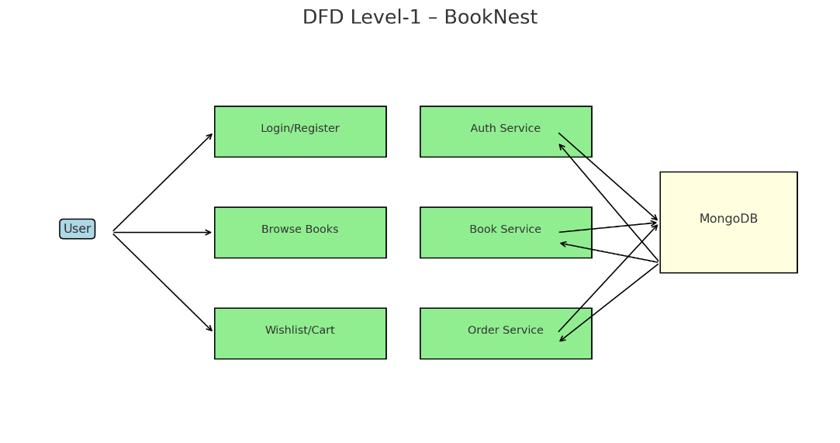

**Example:** [**(Simplified)**](https://developer.ibm.com/patterns/visualize-unstructured-text/)

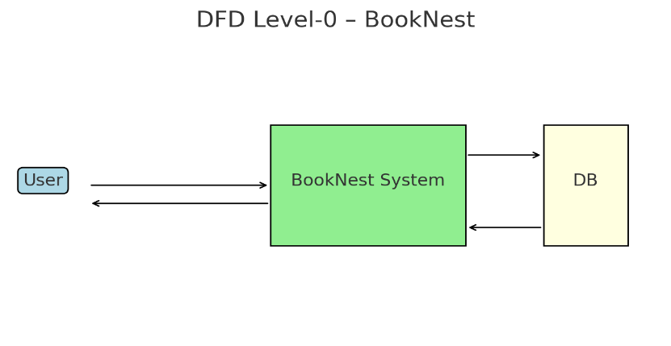

* User sends request (register, login, browse books, order, wishlist)

Data flows:

* From user to system through login, book filters, wishlist, and cart interactions
* System reads/writes to MongoDB (user, book, order, wishlist collections)
* System responds with book list, dashboard, confirmation
* System stores/updates data in MongoDB

**User Stories**

| **User Type** | **Functional Requirement (Epic)** | **User Story #** | **User Story / Task** | **Acceptance Criteria** | **Priority** | **Release** |
| --- | --- | --- | --- | --- | --- | --- |
| Customer (Web) | Registration | USN-1 | As a user, I can register with email and password. | I can access my dashboard | High | Sprint-1 |
| Customer (Web) | Registration | USN-2 | As a user, I receive a confirmation email after registration. | I receive & confirm via email | High | Sprint-1 |
| Customer (Web) | Registration (OAuth) | USN-4 | As a user, I can register using Gmail authentication. | I register via Gmail | Medium | Sprint-1 |
| Customer (Web) | Login | USN-5 | As a user, I can log in using email and password. | I access my dashboard | High | Sprint-1 |
| Customer (Web) | Dashboard | USN-6 | As a user, I can view my orders and wishlist on a personalized dashboard. | Dashboard shows my books and orders | High | Sprint-2 |
| Customer (Web) | Wishlist | USN-7 | As a user, I can add/remove books from my wishlist. | Heart icon toggles and saves correctly | Medium | Sprint-2 |
| Customer (Web) | Book Browsing | USN-8 | As a user, I can browse and filter books by genre/author. | Filters update book list instantly | High | Sprint-2 |
| Customer (Web) | Order Placement | USN-9 | As a user, I can add books to my cart and place orders with delivery address. | Order confirms with address saved | High | Sprint-3 |
| Customer (Web) | Profile Management | USN-10 | As a user, I can update my profile (name/email/password). | Changes are saved and reflected on next login | Medium | Sprint-3 |
| Administrator | Admin Dashboard | USN-11 | As an admin, I can manage all books, users, and orders. | Admin panel updates backend & reflects in UI | High | Sprint-4 |
| Administrator | Order Management | USN-12 | As an admin, I can update order status (Processing, Shipped, Delivered). | Orders update and show status in user dashboard | Medium | Sprint-4 |
| Administrator | Book Image Upload | USN-13 | As an admin, I can upload book images during book creation/editing. | Book cover appears correctly in book listing | Medium | Sprint-4 |